Now that we know somewhat about criminal offences, let’s practice using them! In this activity, you will be assigned a case and will have to either prosecute or defend the alleged criminal. For this example let’s call her Ms.Bridge and she is charged with Criminal Negligence AND Assault.
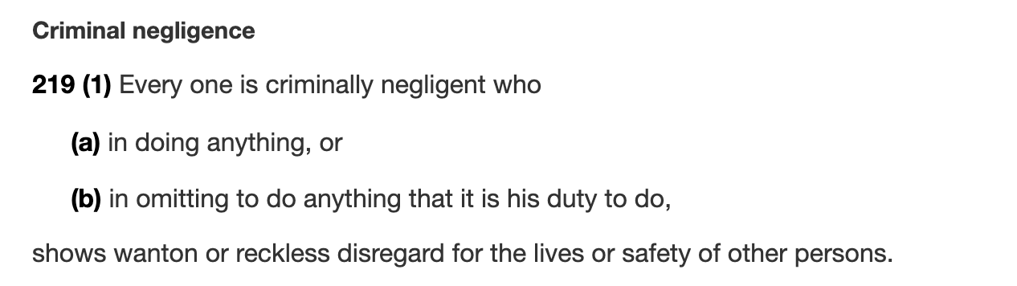
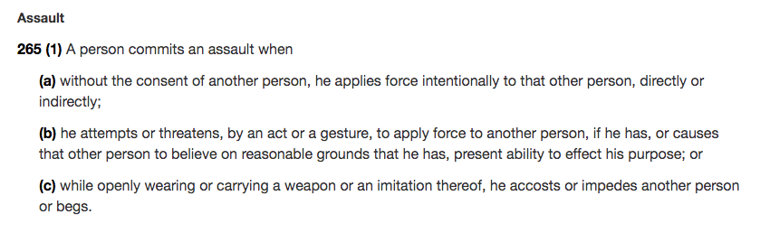
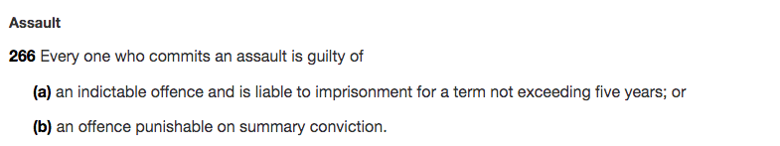

Ex. The prosecution may want to seek the maximum penalty, whereas Defence would want to seek a reduced penalty or ‘non-guilty’.

- Watch this video: https://youtu.be/i-ogx54G2rI

TIPS:
- Begin with: “I believe that ___________ is a (inappropriate or appropriate) charge and ________should receive ________________ (X amount of time in jail, or a X amount in a fine or X alternative) because...
- When coming up with your reasons, think about what in the video makes the person either guilty or not guilty. Could it be what they’re doing? Where they are? What they’re saying? Use any of these to your advantage.
- YOU ONLY HAVE THIS VIDEO TO GO OFF OF.
- Remember it has to be CONVINCING, not “correct”.
- End with: For these reasons Ms.___________ should receive ______________

